**Name: Cornelio, Cedric E. BSIT-3B Date: March 3, 2025**

**Stored Procedures**

**Question 1: What is a Stored Procedure?**

* By the name itself, it a procedure that is being stored or a set of SQL statements that is saved or stored in the database which can be executed when it is needed. It is useful because it reduces the amount of code that needs to be rewritten and also improves security. For example, if a company need to calculated the salaries of their employees every month, instead of writing the same SQL query repeatedly, they can just create a stored procedure that automates the task when needed.

**Question 2: How Do Stored Procedures Improve Performance?**

* Stored procedures improve performance because they are precompiled, which means that the SQL Server processes them once and stored the execution plan making the execution faster when used. They also help reduce network traffic since only the procedure name and parameters are sent instead of the whole SQL query and by the help of the stored procedure, you also don’t need to write the whole SQL query every time you need it, making it more efficient and reducing the chances of errors.

**Question 3: Explain Input and Output Parameters in Stored Procedures**

* In Stored Procedures, input and output parameters are used to pass values into the procedure and retrieve values from it. Input parameters allow users to pass values into the stored procedures to allow external data for processing, while the output parameters return the value after execution which can be modified within the procedure. Here is an example of a stored procedure that uses both input and output parameters:

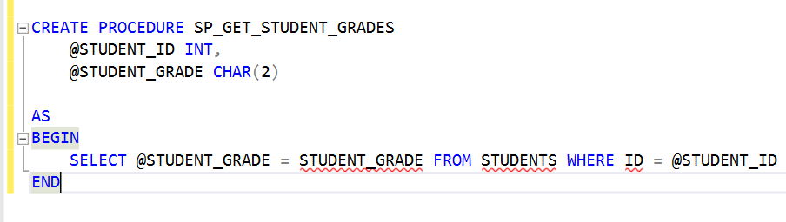

The input parameter is the @STUDENT_ID and the output parameter is the @STUDENT_GRADE. The stored procedure needs and Input of the student’s id in order to return the student’s grade.

**Question 4: How Can Stored Procedures Enhance Security?**

* Stored Procedures enhance database security by restricting direct access to tables and enforcing controlled execution of SQL statements. It also helps prevent SQL injection attacks by using parameter queries which ensures that the user inputs are treated as data rather that executable SQL code, eliminating the risk of malicious SQL statements being injected into queries. Making the database more secure against unauthorized access and data manipulation.

**Question 5: Debugging and Maintaining Stored Procedures**

* Best practices in for debugging stored procedures includes using PRINT to check variable status. You can also use TRY…CATCH for error handling, and testing procedures with different inputs. Documentation is important because it helps you or other developers understand the purpose, parameters, logic, and expected outputs of a stored procedure. It can also make future maintenance easier.

**SQL Views**

**Question 1: Purpose of Views**

* SQL views functions as a virtual table that display the result of a predefined query, making easier to manage complex queries, improve security, and enhance data abstraction. Unlike the physical table, views do not store data directly, instead they dynamically fetch information from underlying tables. This makes them valuable for controlling access to sensitive data by allowing only specific columns or rows to be visible to certain users. For example, a university database may have a STUDENT_INFOVIEW that only shows student names, courses, and classes instead of all their personal details like address and contact information. This helps maintain data security while providing a structured and simplified way to access relevant information.

**Question 2: Simplifying Queries**

* When working with complex queries that join multiple tables and apply various filters, using view can simplify the process by encapsulating the query into a reusable virtual table. Instead of writing the same long query repeatedly, users can retrieve the necessary data by simply selecting from the view. This not only makes queries easier to read and manage but also reduces the risk of errors and improves performance by optimizing query execution.

**Question 3: Data Security**

* Views help secure data by restricting access to specific columns. For example, in a company database, employees should not see salary details of others. A view can be created to show employee names and departments but hide salary details. In this way, users with access to this view cannot see salary information.

**Question 4: Real-World Application**

* In a university database, a view can be helpful for students to easily access their academic records without exposing unnecessary administrative or faculty details. For example, a view can be created to allow students to check their grades, enrolled courses, and instructors without displaying sensitive information like other students' grades or faculty salaries. This view would be beneficial because it simplifies access to academic records, ensuring students see only their own data. It also improves database security by restricting access to sensitive details while making academic information easily accessible for students.